# File permissions in Linux

## Project description

After a review, the research team of my organization determined that the level of file permissions of the organization needed to be updated because it does not reflect the expected standard. In order to secure company data, I was tasked to manage the authorisation of access to files. This involved authorizing appropriate users and restricting access as well as removing all unauthorized users.

## Check file and directory details

To check the permissions, the command line used is ls -la

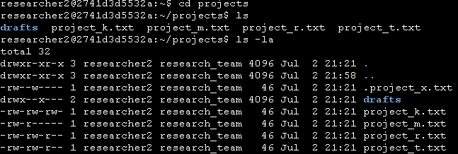

Describe the permissions string

projects_k.txt

The permission string for the above file is : drw-rw-rw-

D means that it is a directory

The string shows the following permissions:

The User can only read and write and has no permission to execute.

Group can only read and write but is not authorized to execute.

Others can read and write but cannot execute.

## 

## 

## Change file permissions

project_k.txt needs its permission to be modified because it goes contrary to the company policy that others are not permitted to write. To modify it, the following command will be used:

chmod o-w project_k.txt

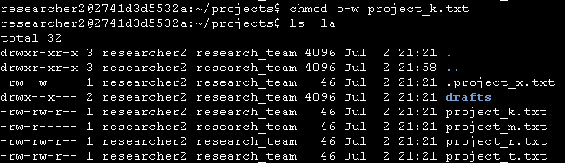

## Change file permissions on a hidden file

The command line is as follows: chmod u-w,g-w,g+r .project_x.txt

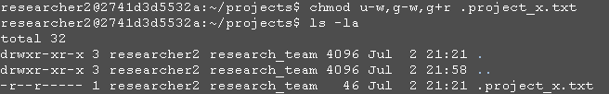

## Change directory permissions

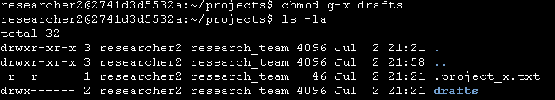

## Summary

I have successfully updated the file permissions of my organization to the expected level. My first step was to use the ls -la command line to display the details of the files present in the projects directory and to ascertain the current level of file permissions. Afterwards, I modified many file permissions using the chmod command line to reflect the expected standard.